1. Elevate your user access to root;

For switching user we use command ‘su’ so in this case we will use the command ‘sudo su’ in order to change the access to root.

After that it will require to type the password for the current user that you are using at the moment

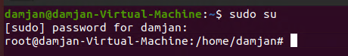

1. add a new user to your Linux OS and set a password for it;

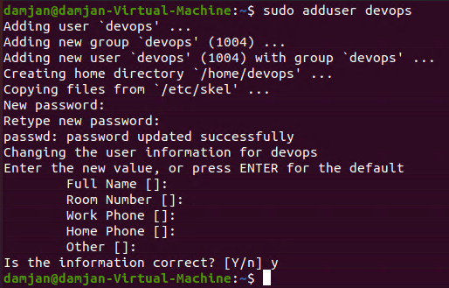

1. Test if you can log in using that user;



1. Using grep command check if the user is created;



1. grep the UID of each user;

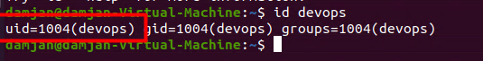

1. Find out the GID of the created user;

Same command we use as number5 exercise



1. Change the password of the user and force it to change the pass on his next login;

For changing the password we use the command ‘sudo passwd “username” ‘

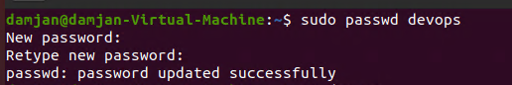

Forcing the password to be changed on the login we will use the command ‘sudo passwd -e “username” ‘



After that if we want to login with that user it will be showed that we are required to change the password

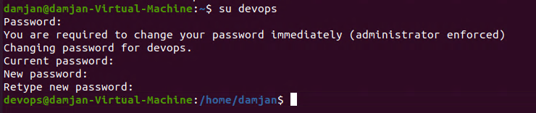

1. Add a new user and set an expiration date for it, with a five-day warning period;

For adding user we will the simple command ‘sudo adduser “username”

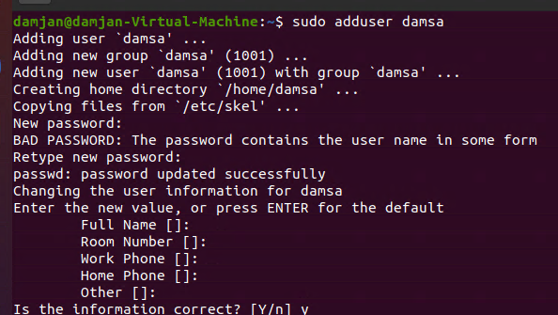

For setting the expiration date and stating the 5 day warning we will use the command “chage ‘the user’ “

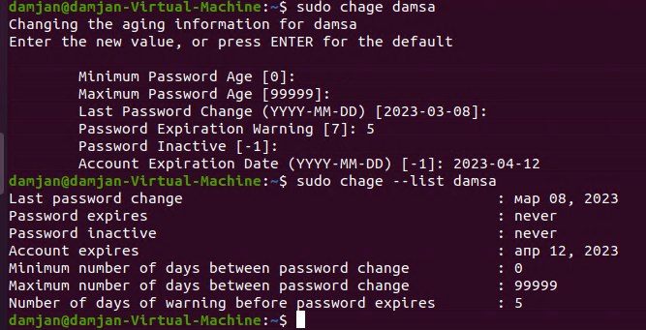

1. Create a new group;

For creating new group we use the command ‘sudo addgroup “groupname” ‘

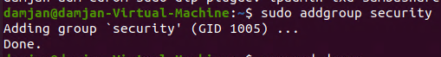

1. Assign the two new users to that group;

for this we will use sudo since we can access the /etc/passwd file

so “ sudo usermod -g ‘groupname’ ‘username’

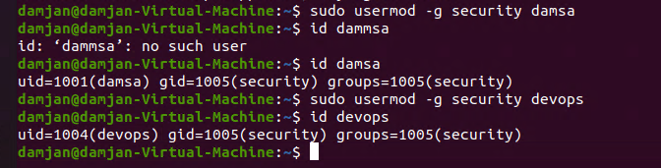

1. Lock one of the user accounts;

Sudo usermod -L ‘username’



To check if the user is locked we use : grep devops /etc/shadow



The exclamation mark means the user us Locked

In order to unlock the user we will use sudo usermod -U ‘username’

1. Change the shell of one user to tcsh;





============================================================================================

==================================

1. Make sure your home directory has “execute” access enabled for group and other.

To make sure the home directory has X permission we will user

Sudo chmod +x /home

1. Change to your home directory, and create a directory called labs;

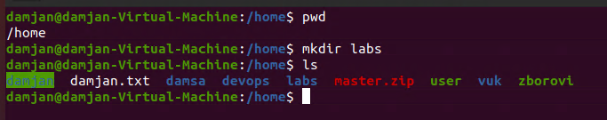

1. Create an empty file in labs directory

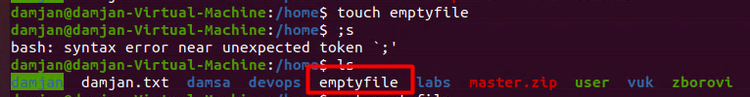

1. Change permissions of file to rwx-rwx-rwx

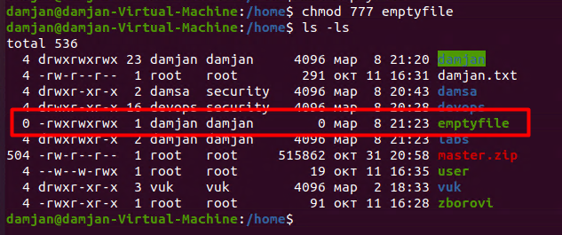

1. List the file. What color is the file?



1. Change the permissions back to rx-rw-rw



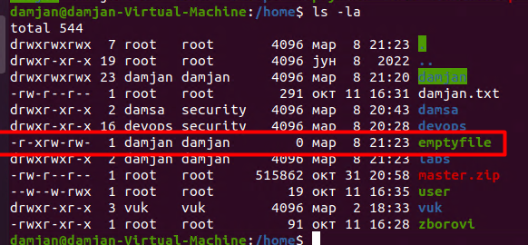

1. Check what owners does the file have.



1. Change the user ownership of the file to another user;

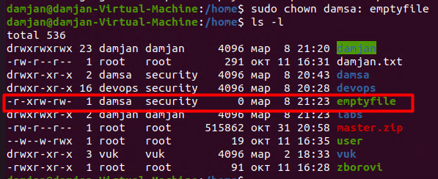

1. Create a group called group1 and assign two users to the group;

Creating group

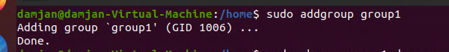

Assigning users



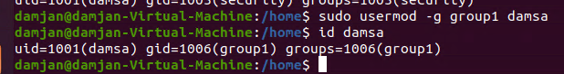

1. Create a file called group1.txt and redirect below input into the file:

“This is our group test file”.

We will use the command echo “ this is our group test file” > group1.txt

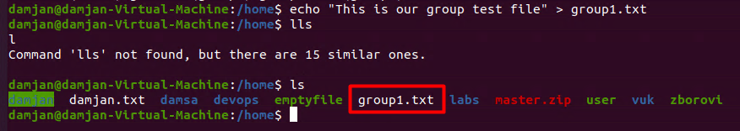

1. Change the group of the file to one of your users;

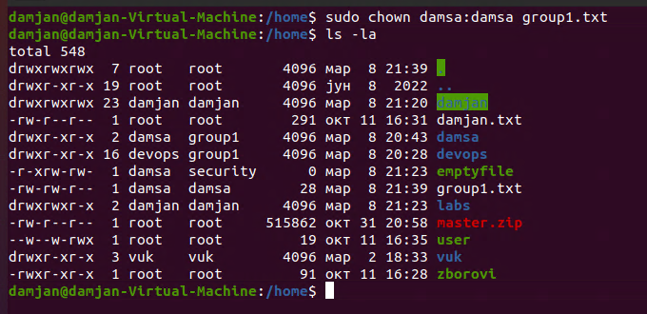

1. Give members of the group group1 read/write access to this file?

